 |  | Reservation Form  November 27(Thu)-29(Sat), 2025 |  |  |  |  |  | 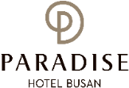
1. GENERAL INFORMATION |  |  |  |  |  |  |  | 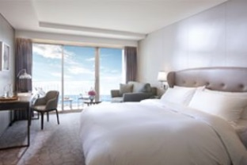  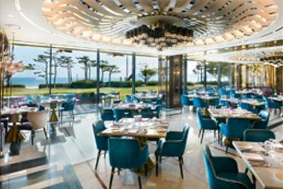  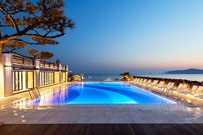
*Check-In Date: |  |  |  | *Check-Out Date:
*Name(Family/Given): |  |  |  | *Number of Persons:
*Telephone: |  |  |  | *E-mail:
2. CREDIT CARD GUARANTEE
*Credit Card: ☐Visa, ☐Master, ☐Amex (4Digital number: ), ☐Other( )
*Card Number: |  |  |  |  | *Signature:
*Expiry Date(mm/yy):
*Holder’s Name:
The above card information is used for the guarantee of your reservation only, and the payment will be made upon check-in.
I agree that using the above credit card information to be used in relation to cancellation fees and the occurrence of the No-Show.
상기 카드 정보는 예약 보증을 위해서만 사용되며, 위약금 발생 시 사용하는 것에 동의합니다. 실제 결제는 체크인 시 현장에서 진행됩니다.
3. SPECIAL ROOM RATE (UNIT: KOREAN WON)
Room Type |  |  | *Monday - Thursday |  |  | *Friday | *Saturday |  | *Sunday
Main Bldg. | Deluxe City View |  | ☐ 242,000 (King Bed)  ☐ 242,200 (Twin Beds) |  |  | Surcharge  +72,600  (추가요금) | Surcharge  +157,300  (추가요금) |  | Surcharge  +36,300  (추가요금)
Annex Bldg. | Deluxe City View |  | ☐ 266,200 (King Bed)  ☐ 266,200 (Twin Beds) |  |  | Surcharge  +72,600  (추가요금) |  |  | Surcharge  +36,300  (추가요금)
Annex Bldg. | Deluxe Ocean View |  | ☐ 290,400 (King Bed) |  |  | Surcharge  +72,600  (추가요금) |  |  | Surcharge  +36,300  (추가요금)
Main Bldg. | Deluxe Ocean Terrace View |  | ☐ 314,600 (King Bed)  ☐ 314,600 (Twin Beds) |  |  | Surcharge  +72,600  (추가요금) |  |  | Surcharge  +36,300  (추가요금)
Annex Bldg. | Deluxe Ocean Terrace View |  | ☐ 338,800 (King Bed)  ☐ 338,800 (Twin Beds) |  |  | Surcharge  +72,600  (추가요금) |  |  | Surcharge  +36,300  (추가요금)
*Extra Bed(Main Bldg.) or Extra Bedding(Annex Bldg.): KRW 72,600(Per Night)
*Breakfast Buffet (Main Bldg. 1F. On the Plate, 06:30-10:00): KRW 50,000(Per Person)
*Special Request:
The rates above are non-commissionable, and they are Inclusive of 10% Service Charge and 11% Government Tax. (Breakfast not included)
Number of Guests: 2 Adults. (Up to 2 children can stay free of charge) All rooms of the Building are non-smoking areas.
Check-in time is 3p.m.(15h00) Check-out time is 11:00 a.m.(11h00). Past the mentioned check-out time, the following rates will be applied
(Until 3p.m.(15h00): 50% of the room rate, After 3p.m.(15h00): 100% of the room rate)
Benefits Included: Outdoor Ocean pool(Swimming pool), Fitness Club, Business Center, Kids Villages, Wi-Fi
The Leisure facilities (Ocean Pool, Fitness Club, Sauna, Spa Cimer) will be closed for maintenance every fourth Wednesday each month.
상기 객실 요금에는 봉사료 및 세금이 포함 되어 있으며, 조식은 별도입니다. 전 객실은 금연 객실로 지정되며, 체크인은 15시, 체크아웃은 11시입니다.
기준 투숙 인원은 성인2인이며, 소인은 최대 2인 까지는 추가 요금 없이 숙박 가능합니다. (단, 추가 침대 또는 성인 인원 추가 시: 박당 72,600원 별도)
투숙객은 야외수영장, 피트니스클럽, 비즈니스센터, 키즈 빌리지 무료 이용 가능합니다. 매월 4주차 수요일은 레저시설 휴무입니다.
CANCELLATION POLICY
Amendaments, Cancellations are availble upon following regulations: Hotel has the right to claim all room charge, which would be deducted from your guaranteed credit card. Cancellation or No-Show after the room reservation is being charged as below:
1) From 5days to 3days prior to Arrival date(~18:00): 50% of the Room charge
2) From 2days or less prior to Arrival date(Includling No-Show): 100% of the Room chrarge
위약금 규정 1) 체크인 5일 전~3일 전 취소시 위약금: 객실료의 50% 부과, 2) 체크인 2일 전~당일 취소 시(노쇼포함): 객실료의 100% 부과됩니다.
Please send your reservation form to: res@paradian.com (Tel. +82-51-749-2111~3)

